

MAIRA EMAAN NASIR

REG NO: 2430-0153

PROGRAMMING FUNDAMENTALS

DEPARTMENT: BSCS

LAB TASK: 03

**QUESTION: 1**

**WORKING WITH DIFFERENT DATA TYPES**

**CODE:**

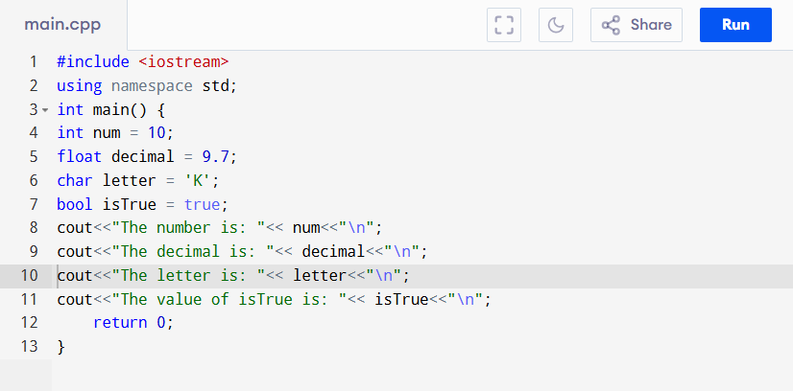

**OUTPUT:**

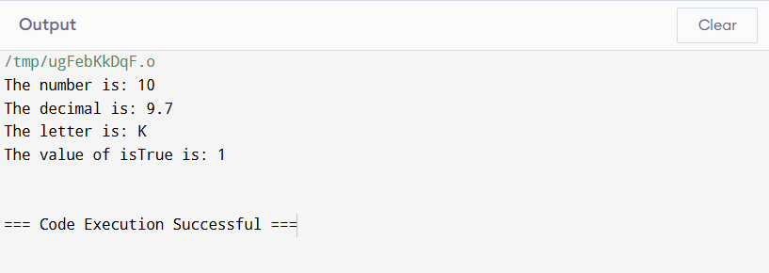

**QUESTION: 02**

**TAKING INPUT FROM THE USER**

**CODE:**

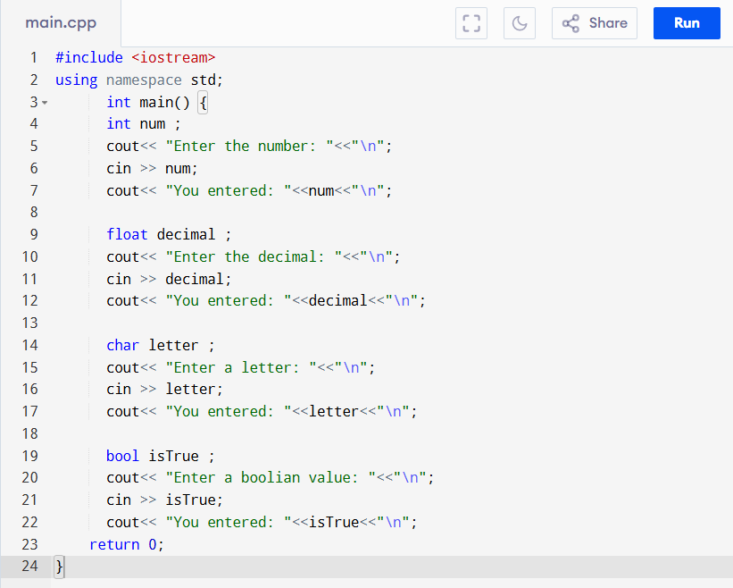

**OUTPUT:**

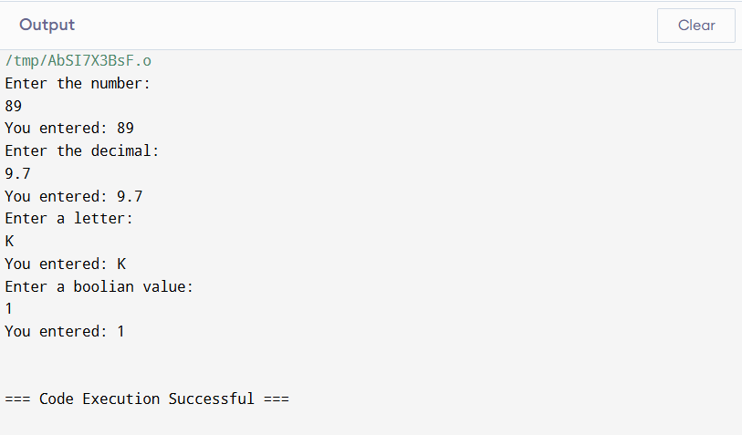

**QUESTION: 03**

**USING ASSIGNMENT OPERATORS**

**CODE:**

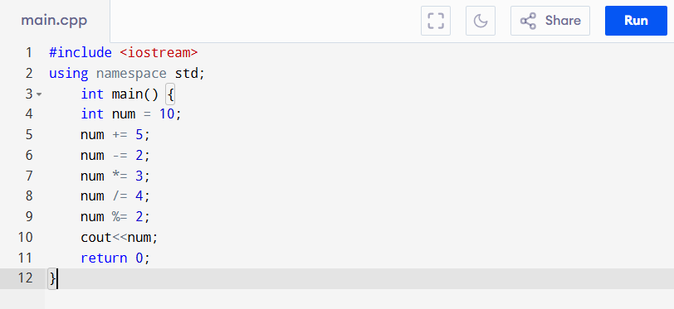

**OUTPUT:**

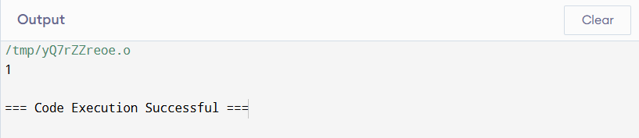

**QUESTION: 04**

**LOGICAL OPERATORS WITH BOOLEAN VALUES**

**CODE:**

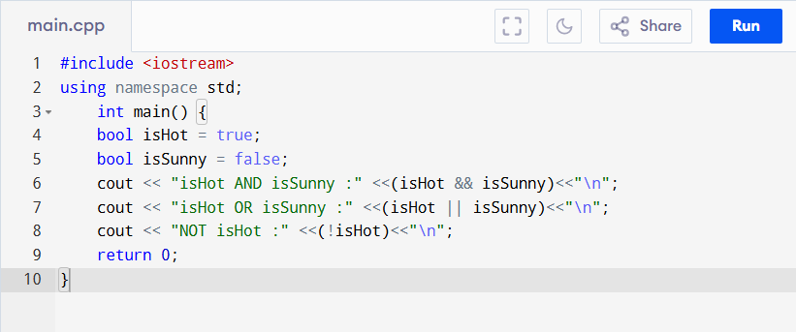

**OUTPUT:**

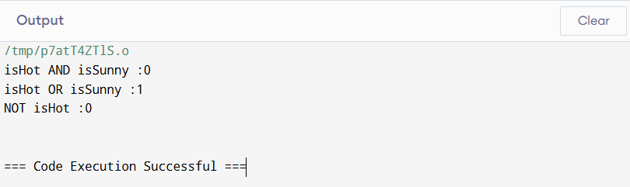

**QUESTION: 05**

**COMPARISON OPERATORS WITH USER INPUT**

**CODE:**

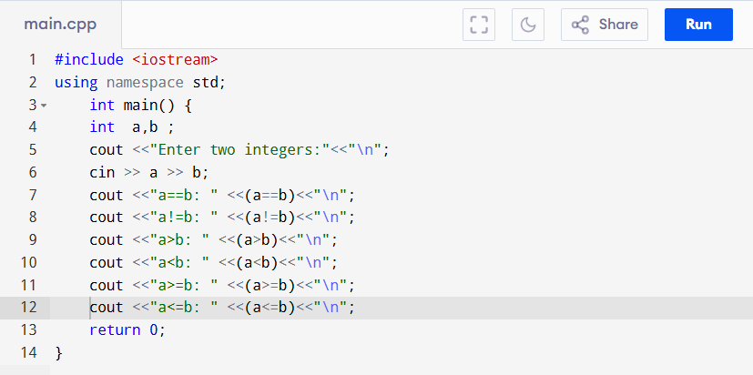

**OUTPUT:**

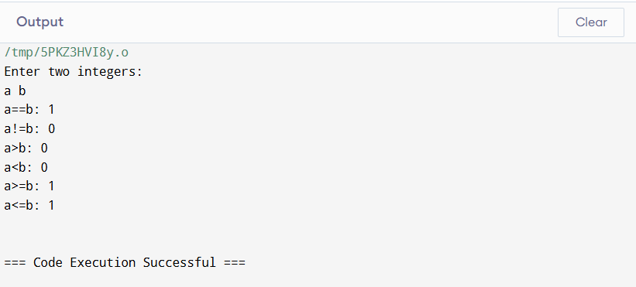

**QUESTION: 06**

**USING TERNARY OPERATORS**

**CODE:**

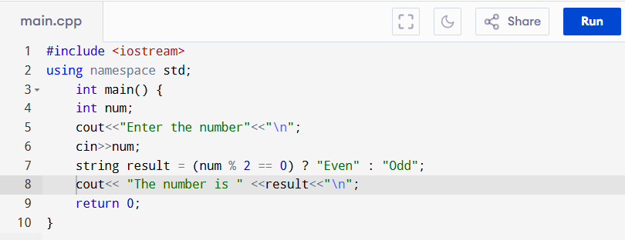

**OUTPUT:**

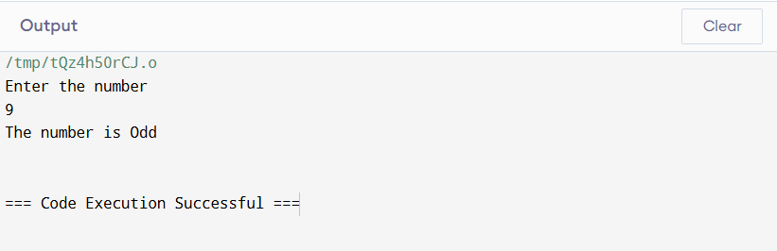

**QUESTION: 07**

**FIND THE AREA OF A RECTANGULAR GARDEN.**

**DATA:**

Length = 10 meters

Width = 5 meters

**CODE:**

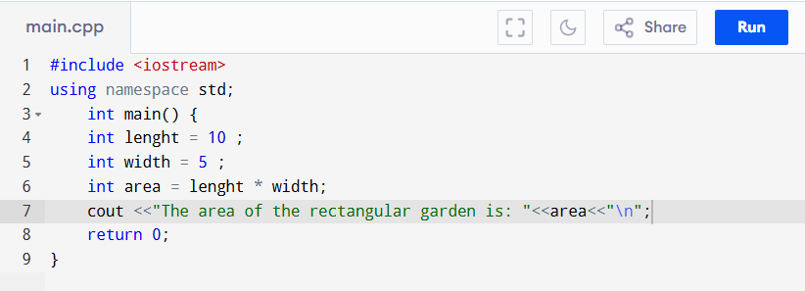

**OUTPUT:**

